SIMATS ENGINEERING (SAVEETHA SCHOOL OF ENGINEERING)
Department of Computer Science and Engineering

Course Code: | CSA10 | Course Title: | Software Engineering
CO Assessed: | CO4 | Assessment: | Assessment Tool 2 - Test Case  Design Assignment
Weightage: | 20% | Total Marks: | 25
CO3 Statement: | Ci/Cd Pipeline Design Document  Smart Pharmaceutical Supply Chain Counterfeit Detection Platform
Student Name: |  | Reg. No.: | 192421342
Date: |  | Duration: | 60 minutes

Code of Conduct
I Ganeshwar S certify that this submission is my original work and that I have adhered to the guidelines specified for this assessment. I understand that any violation of academic integrity rules will result in disciplinary action.
Signature of the Student: Ganeshwar S

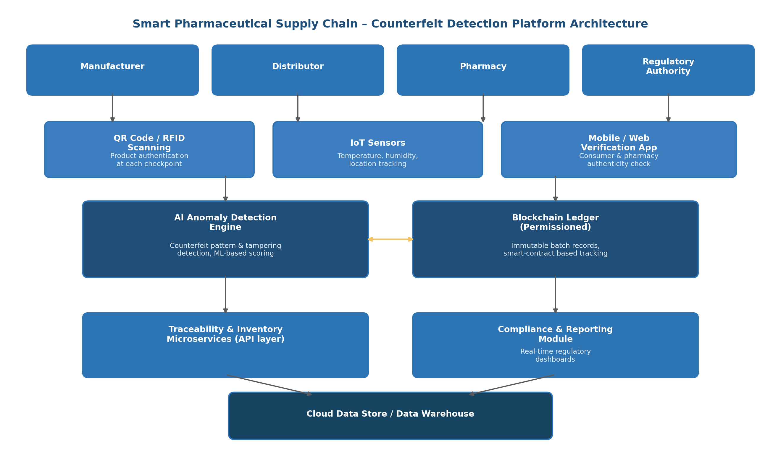

Course Code: CSA10 | Course Title: Software Engineering
CO Assessed: CO4 | Assessment: Assessment Tool 2 – CI/CD Pipeline Design Exercise
Problem Statement 36: Smart Pharmaceutical Supply Chain Counterfeit Detection Platform

1. Problem Context and CI/CD Requirement Analysis
1.1 Project Overview
Counterfeit medicines continue to enter pharmaceutical supply chains because product traceability is weak and inventory systems are fragmented across manufacturers, distributors, pharmacies, and regulators. The proposed platform authenticates medicines using QR codes and RFID, applies AI-based anomaly detection to flag counterfeit or tampered products, monitors storage and transport conditions through IoT sensors, and records every transaction on a permissioned blockchain ledger so that all stakeholders can view a single, tamper-proof source of truth.
Because the system directly affects patient safety, regulatory compliance, and financial trust across multiple organisations, its software delivery process must be automated, auditable, and resistant to human error. A CI/CD pipeline is therefore essential to enable frequent, reliable releases of the AI models, blockchain smart contracts, and traceability microservices without compromising data integrity or system availability.
1.2 Identified CI/CD Needs
- Multi-service delivery: the platform is composed of an AI anomaly detection engine, a blockchain ledger, microservices, and mobile/web applications, so the pipeline must build, test, and deploy several independently versioned components.
- High reliability and zero silent failure: a missed defect could allow a counterfeit batch to pass verification, so automated testing and quality gates must run on every change.
- Regulatory traceability: every build, test result, and deployment must be logged and auditable to satisfy pharmaceutical regulatory authorities.
- Frequent, low-risk releases: AI detection models and smart contracts evolve often and need safe rolling/blue-green deployment with fast rollback.
- Strong security posture: the pipeline must guard against supply-chain attacks on its own build artifacts, given the sensitivity of health-related data.
- Scalability across environments: the pipeline must promote builds consistently from development to staging (including a blockchain testnet) to production.

2. CI/CD Pipeline Architecture and Workflow
The pipeline is triggered on every code commit or pull request and progresses through six automated stages, from source control to production deployment. Each stage acts as a quality gate: a failure at any stage halts the pipeline and notifies the responsible developer, preventing defective or insecure code from advancing.
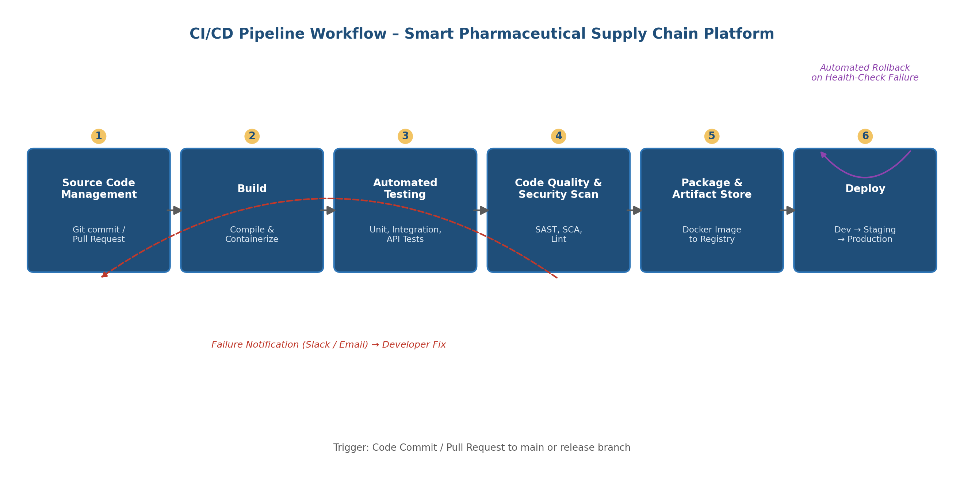
Figure 1: End-to-end CI/CD pipeline workflow for the pharmaceutical supply chain platform
2.1 Stage-by-Stage Workflow
- Source Code Management – Developers push code to feature branches in Git; a pull request into the main/release branch automatically triggers the pipeline.
- Build – The application, AI model, and smart-contract code are compiled and packaged into Docker containers with dependency resolution.
- Automated Testing – Unit, integration, and API tests validate business logic, QR/RFID authentication, and blockchain transaction handling.
- Code Quality and Security Scan – Static analysis, dependency (software composition analysis) scanning, and linting check for vulnerabilities and code smells.
- Packaging and Artifact Storage – Verified container images and smart-contract bytecode are versioned and pushed to an artifact/container registry.
- Deployment – Artifacts are promoted through Development, Testing/Staging, and Production environments using automated deployment scripts.

3. Tools and Technology Selection
The following tools were selected for each pipeline stage based on industry adoption, integration support for blockchain and containerised microservices, and suitability for a healthcare-grade compliance environment.
Pipeline Stage | Selected Tool(s) | Justification
Source Code Management | Git + GitHub / GitLab | Industry-standard version control with built-in pull-request review and webhook triggers for automation.
CI/CD Orchestration | Jenkins / GitHub Actions | Flexible pipeline-as-code, wide plugin ecosystem, and native support for containerised and blockchain build steps.
Build & Containerization | Docker, Maven/Gradle or npm | Ensures consistent, reproducible builds across development, staging, and production.
Automated Testing | JUnit / PyTest, Postman/Newman, Selenium | Covers unit, API, and UI-level verification of authentication and traceability workflows.
Code Quality & Security | SonarQube, OWASP Dependency-Check, Snyk | Detects code smells, vulnerable dependencies, and security flaws before deployment.
Blockchain Testing | Truffle / Hardhat, Ganache testnet | Enables automated smart-contract testing and simulated ledger transactions pre-production.
Artifact Repository | Docker Hub / Nexus / JFrog Artifactory | Central, versioned storage for container images and build artifacts with access control.
Deployment & Orchestration | Kubernetes, Helm | Automates scalable, rolling, and blue-green deployments across environments.
Monitoring & Logging | Prometheus, Grafana, ELK Stack | Provides real-time visibility, alerting, and audit-ready logs for regulatory compliance.
Notifications | Slack / Microsoft Teams, Email (SMTP) | Immediate alerts to developers and QA on build, test, or deployment failures.

4. Automated Testing Strategy
A layered testing strategy is embedded directly into the pipeline so that every change is verified automatically before it can progress, minimising the risk of counterfeit-detection failures reaching production.
4.1 Testing Layers
- Unit Testing – Validates individual functions such as QR/RFID decoding, anomaly-scoring logic, and smart-contract methods; run on every commit.
- Integration Testing – Verifies interaction between microservices, the blockchain ledger, and the AI detection engine, including IoT sensor data ingestion.
- API Testing – Automated Postman/Newman collections validate traceability and compliance-reporting endpoints for correctness and response integrity.
- Smart-Contract Testing – Hardhat/Truffle test suites simulate batch registration and transfer transactions on a local blockchain testnet.
- Security Testing – SAST and dependency scanning (SonarQube, Snyk) run on every build; periodic dynamic application security testing (DAST) targets deployed staging endpoints.
- Performance & Load Testing – Simulates high-volume scan events (e.g., festival-season dispatch spikes) using JMeter before production promotion.
- User Acceptance Testing (UAT) – Conducted in the staging environment with sample stakeholder workflows before production sign-off.
4.2 Quality Gate
A build is blocked from progressing to the packaging stage unless unit and integration test coverage exceeds an agreed threshold (e.g., 80%), zero critical security vulnerabilities are found, and static analysis quality gates in SonarQube pass.

5. Deployment Strategy
Builds are promoted sequentially through three environments, each with an approval gate, so that defects are caught before reaching real pharmaceutical stakeholders.
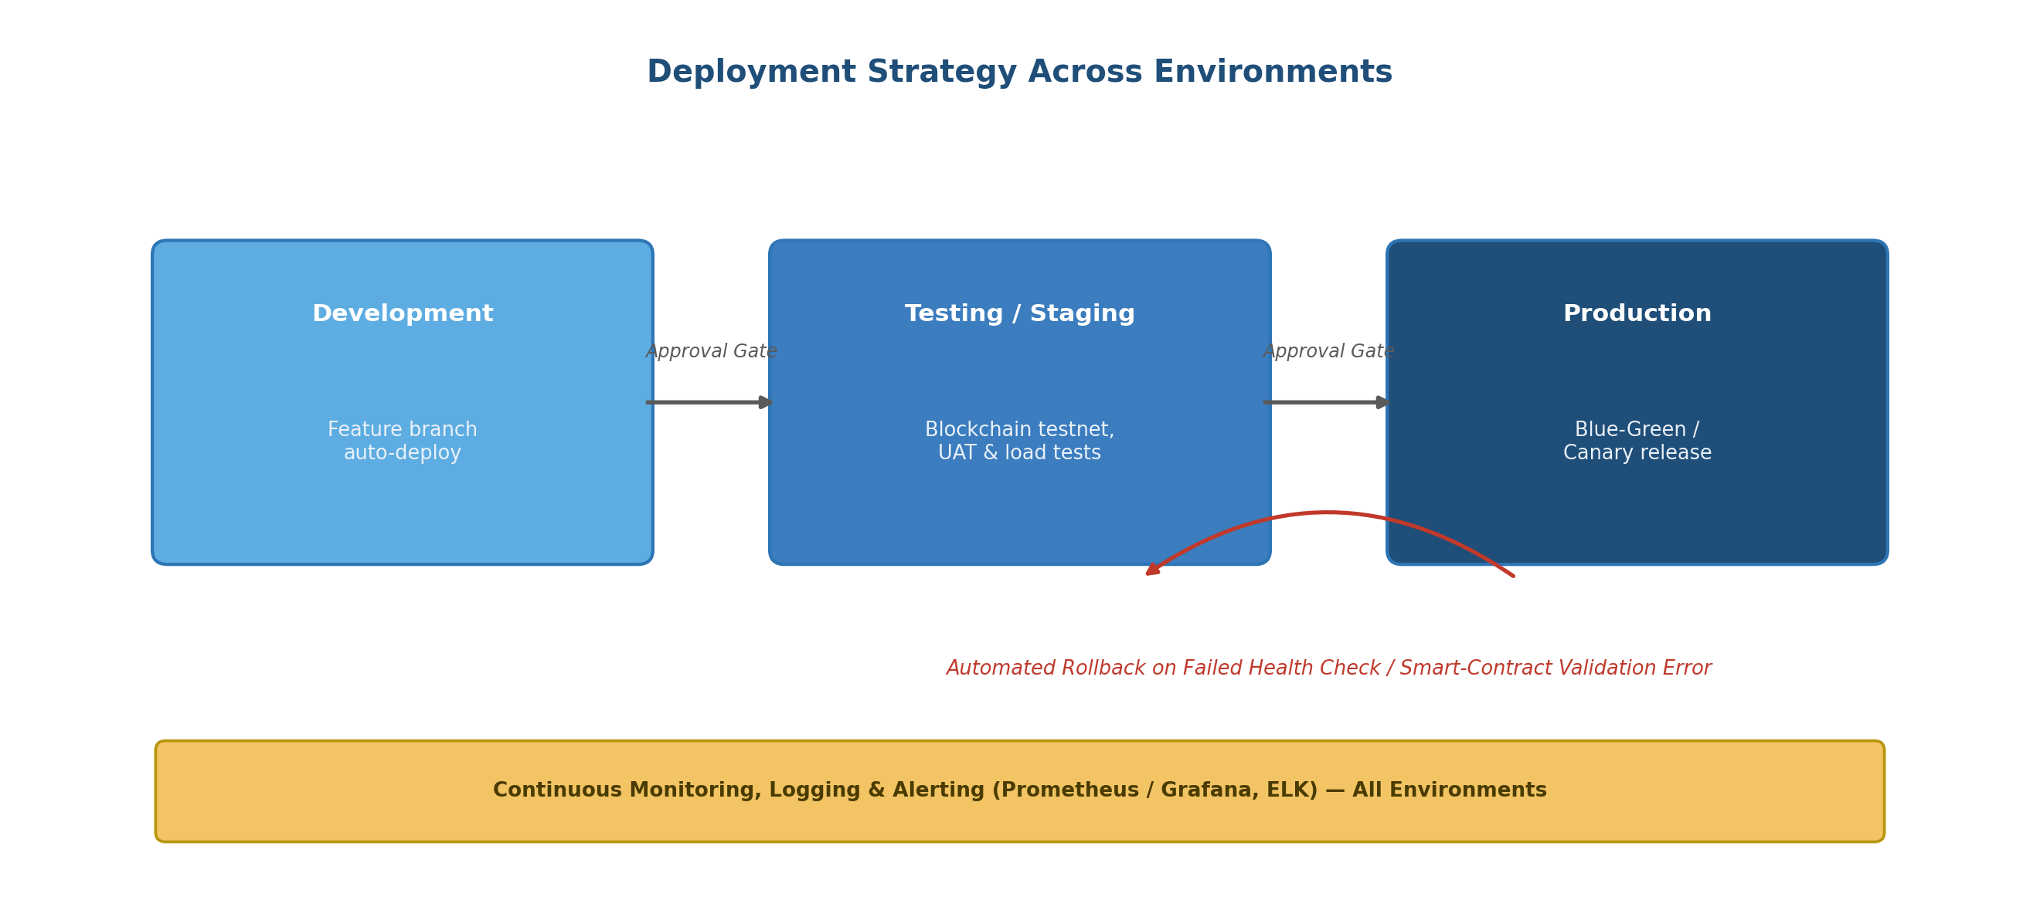
Figure 2: Deployment promotion path with monitoring and automated rollback
Environment | Purpose | Deployment Approach
Development | Continuous integration of feature branches for early feedback. | Automatic deployment on every successful build; ephemeral containers per branch.
Testing / Staging | Integration, UAT, and blockchain-testnet validation under production-like conditions. | Automated deployment after quality gate passes; manual UAT sign-off required.
Production | Live service for manufacturers, distributors, pharmacies, and regulators. | Blue-green or canary release with health checks and gradual traffic shift.
5.1 Rollback Mechanism
Each production deployment is monitored immediately after release using automated health checks (service availability, blockchain node sync status, error rate thresholds). If a health check fails or a smart-contract validation error is detected, the pipeline automatically reroutes traffic back to the last known-good version (blue-green switch) and raises an incident notification, without requiring manual intervention.

6. Security, Quality Checks, and Notifications
6.1 Security Practices Embedded in the Pipeline
- Static Application Security Testing (SAST) on every commit to catch insecure coding patterns.
- Software Composition Analysis (SCA) to detect vulnerable third-party libraries in microservices and blockchain SDKs.
- Secrets management via a vault (e.g., HashiCorp Vault) rather than hard-coded credentials in pipeline scripts.
- Container image scanning before artifacts are pushed to the registry.
- Role-based access control (RBAC) on the CI/CD system so only authorised personnel can approve production deployments.
- Signed container images and smart-contract audit reports to preserve supply-chain integrity of the build itself.
6.2 Notifications
The pipeline sends automated notifications to Slack/Teams channels and email distribution lists at key events: build failure, test failure, security-scan findings, and successful or failed production deployment. This keeps developers, QA engineers, and the DevOps team continuously informed and enables rapid response.
6.3 Compliance and Audit Logging
All pipeline executions, test results, and deployment actions are logged with timestamps and stored centrally, supporting the traceability and audit requirements expected by pharmaceutical regulatory authorities.

7. Conclusion
The proposed CI/CD pipeline enables the Smart Pharmaceutical Supply Chain Counterfeit Detection Platform to be built, tested, and deployed in a fast, secure, and auditable manner. By integrating automated multi-layer testing, static and dynamic security scanning, blockchain-aware validation, and a staged deployment strategy with automated rollback, the pipeline directly supports the platform's core objectives: reducing counterfeit circulation, improving traceability, and enhancing patient safety, while giving manufacturers, distributors, pharmacies, and regulators continuous confidence in every release.

Prepared as part of CSA10 – Software Engineering, CO4 Assessment Tool 2 (CI/CD Pipeline Design Exercise).

